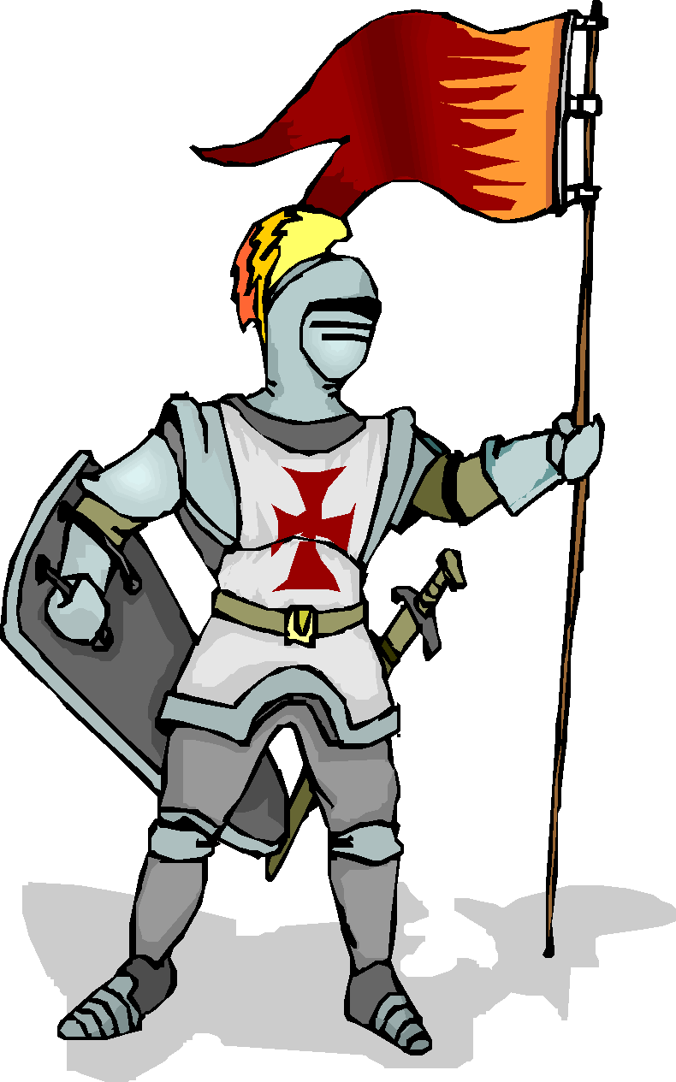
Dear Parents and Students,
We are delighted that your sons/daughters have chosen to be part of the Battle of the Books this year. This fun reading incentive program will encourage students to read a range of genres and authors in the spirit of teamwork and camaraderie.
Parental support will be necessary for teams to successfully compete in the Battle of the Books program. Children may need to make special trips to the public library to find battle books. Some teams may wish to purchase the books in order to study them in the fall and winter before the battles begin. If a team wins the school championship, they will need to participate in the regional championship in March at Westview High school.
Each team will choose a reading themed name less than 4 words in length and a "Squire" (captain). The squire's job is to make sure that each member of the team is reading the assigned books and that the members arrive on time and prepared for each meeting and battle. Teams will also need to decide on the spokesperson. This is the person who checks in with the team and then gives the answers to the judges. This person can change from battle to battle, but needs to be decided while signing this contract. All students are encouraged to read as many of the titles as possible to be the most prepared for their battles, but they are not required to read all of the books. Teams may also take notes and create practice questions for each other. However, no notes or papers of any kind will be permitted at the battles. Teams will meet with Mrs. Bauck & Mrs. Vennes this fall to get ideas on how to study and to touch base with their team. Battles will begin in January.
If you would like further information, you may also check out the website: http://www.oregonbattleofthebooks.org/ To streamline our process this year, we will be communicating to teams via email and information will be on Mrs. Bauck’s website http://shannonbauck.weebly.com/. If your home does not have an email address, please let us know so we can communicate with you another way. Please write your email address legibly so that you may stay informed. If you are not receiving emails after Friday, November 2nd, please email me so you will be placed on my contacts list.
This program is designed to encourage kids to read and discuss books with their friends. Students and/or teams who are not using good sportsmanship during the competition will be asked to sit out one or more battles.

All teams will demonstrate character and good sportsmanship. Win with grace and lose with dignity.
Those players who do not uphold these ideals will be disqualified from the tournament.

Good Luck! Shannon Bauck & Rita Vennes

All team members and their parents must sign below. All teams will check in during lunch/lunch recess on Thursday, October 18th . —NO EXCEPTIONS!! Teams must come together with a completed contract to register for Battle of the Books in the cafeteria.
Please PRINT legibly….
TEAM NAME:_____________________________________________________________________________

First Name | Last Name | Teacher | Email | Student Signature | Parent Signature
*Squire/Captain

1.
2.
3.
4.

*Spokesperson: Please check the box and understand that this will be the expectation of your team
  - We will rotate fairly according to our own team agreement made before battles begin
  - We will have one person be our spokesperson for all battles. That person will be _____________________.

Parent Volunteers Appreciated!
Yes, I would love to help with this program, please contact me:
Name________________________ Child’s Name/Teacher_____________________ Email_________________________

Name________________________ Child’s Name/Teacher_____________________ Email_________________________

