Hear ye! Hear ye!
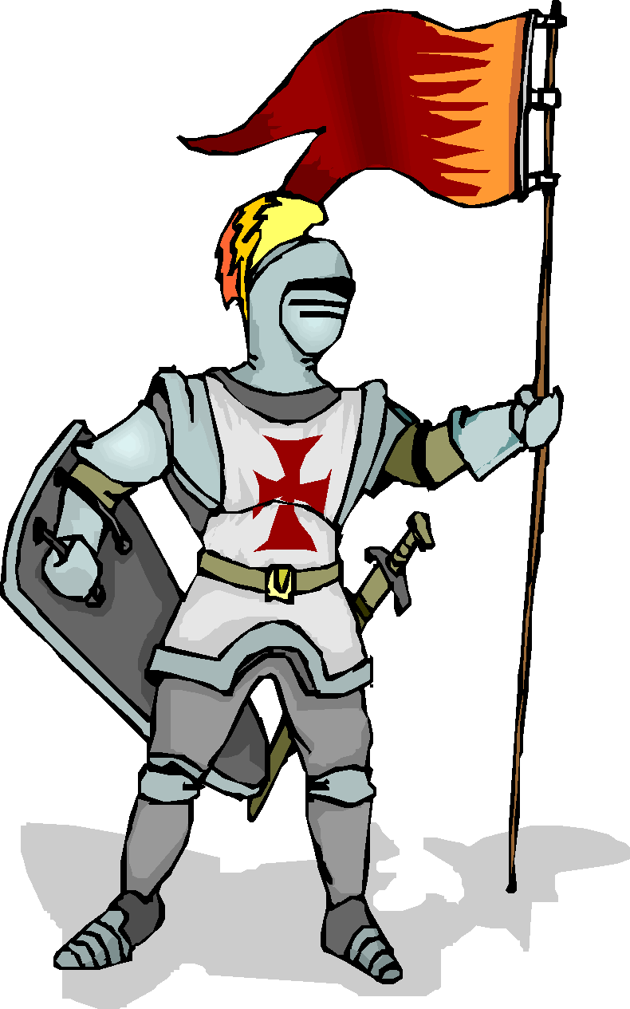
Calling all valiant readers who seek a literary quest.

Join the epic Battle of the books for the 2018-2019 school year.
The Battle of the Books is an exciting tournament of reading. Students will form teams of 4 players. Among them, they will read the list of 16 books prescribed by the royal court of the Oregon Battle of Books. The tournament will begin in January 2019. Battles will be held during lunch recesses until only one team remains in the field. The team that wins the title of Grand Book Battlers will then move on to compete against other "kingdoms" in our area.

Further information can be found on Mrs. Bauck’s website: http://shannonbauck.weebly.com/
Or the state information: http://www.oregonbattleofthebooks.org/

May the best team win the title Champion of the Books!
Details:
- There are 16 books
- You may pick your own team of 4 players. If you CANNOT find a team, sign up and look for prospective teammates on the poster in the library.
- Each student must read at least 8 of the 16 books. You do not have to read all the books. Each team member is encouraged to read as many as possible to be most prepared for the battles.
- Teams must create a team name that fits with the medieval theme of the contest.
- Each team must have a captain.
- All teams will battle at least twice in the preliminary round
- If you wish to join this noble quest, pick up the contract in the library.

Students and parents must sign the contract and register their team on Thursday, October 18th in the cafeteria during lunch—No Exceptions!

